**Online Shopping**



**GROUP MEMBERS**

**“MUHAMMAD HUZAIFA”**

**Student1429963**

**“SALMAN KHAN”**

**Student1407193**

**“HUZAIFA IMRAN”**

**Student1430197**

**“KASHAN”**

**Student1429957**

**“JAMILA MUGHAL”**

**Student1385547**

**CURRICULUM**

***7062***

**BATCH**

***2211C2***

**FACULTY**

***“MS. NEELAM MALIK”***

**CO-ORDINATOR**

***“MS. MUNAZZAH KHAN*”**

**SCREEN SHOTS**

**HOME**

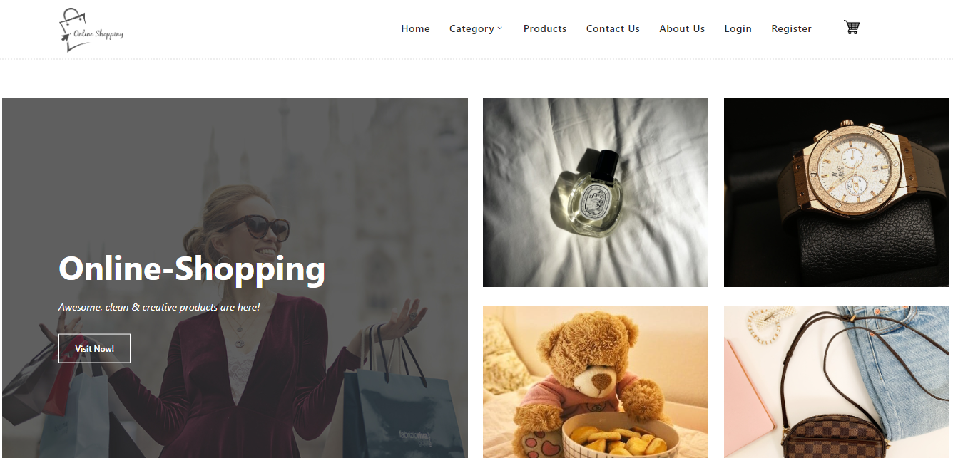

**REGISTER**

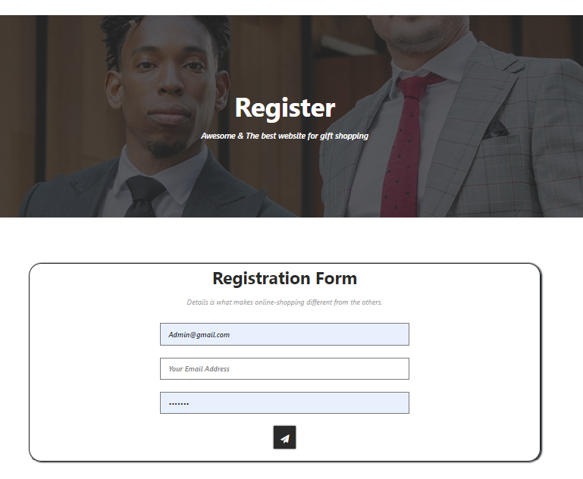

**LOGIN**

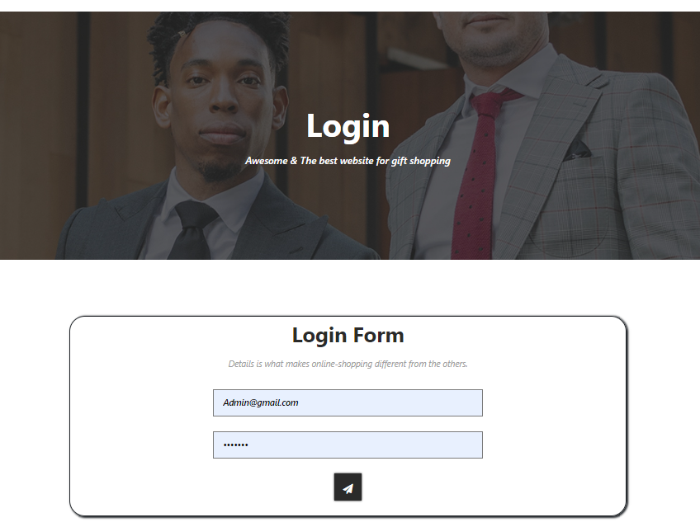

**ABOUT**



**CONTACT US**

